SETUP WiFi MODULE

* Connecting WiFi module with the arduino uno  
    
  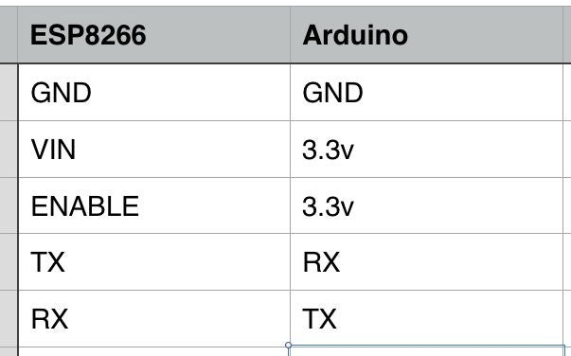
* Power supply with the ID  
    
  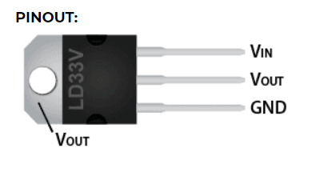

Codes